Name of Event / Activity | Use of vacant land as commercial car park
Person conducting assessment: | Mary Martin, Car Park Manager | Event Date: Ongoing | Time:
Location of Activity or Event: | 2 Smith St, Darwin | Internal o External o (tick ü)
Activity Co-ordinators/Leaders:
Describe the activity or event: | A vacant area of land at the rear of the Christ Church Cathedral/Diocese Office building is being rented out as a parking area to various people and companies.
First Aid Officers if required: | NA

Step 1  List identified hazards and risks | Step 2  Likelihood (Table 1) + Consequence (Table 2)  = Risk level (Table 3) | Step 3  Using the Hierarchy of Control Measures (Table 4) identify suitable control measures to eliminate or minimise the level of risk | Has the risk level reduced?
Hazard or Risk | Risk Rating | Control Measures/Actions to be Taken | Y/N
Cars parked are damaged by falling trees/tree branches | Low | All people/companies renting car parking spaces in the Cathedral Car Park sign rental agreements, these agreements detail the Terms and Conditions and liability limitations. In addition, there are signs at the entrance to and within the car park advising the people are parking at the own risk.  Visual inspections of the trees in the area are carried out on a regular basis and a professional inspection is carried out annually and trees that are considered unstable or degraded are treated or removed | Y
Cars being parked are damaged either deliberately or unintentionally by people who access the car park or by itinerants who loiter in the area | Low | All people/companies renting car parking spaces in the Cathedral Car Park sign rental agreements, these agreements detail the Terms and Conditions and liability limitations. In addition, there are signs at the entrance to and within the car park advising the people are parking at the own risk.  Arrangements have been made with the Darwin City Council and the Waterfront for their security patrols/ people to include the car park area and to move on itinerants. | Y
Physical injury to the vehicle owners or others accessing the car park. | Low | There are signs at the entrance to and within the car park advising the people are entering the car park at the own risk. | Y
Cars are damaged by other vehicles using the car park | Low | There are signs at the entrance to and within the car park advising the people are entering the car park at the own risk. | Y

PERMISSION TO PROCEED

Review Completed By: _________________________________________________________________________________________

Role of the Reviewer: ___________________________________________________________

Date Completed:_______________________________________________________________

Outcome of Risk Assessment ( apply the legend above and tick ü)
Safe | o | Unsafe (requires review of controls) | o | Unsafe (activity is not to be attempted) | o

Sign-off to confirm activity and controls are acceptable and able to occur
Leader-in-Charge/Officer |  | Date:

Other notes:

Questions to consider when assessing the activity or event: (Note the following is not an exhaustive list)
- Is this activity occuring on the Parish grounds or in an external location not under Parish control?
- Is this activity being run by external contractors? If yes, obtained copies of current public liability insurance certificates and or qualifications, and safe operating procedures?
- How many persons will be involved in this activity or event at the one time? Over 500 people requires declaration to Insurers.
- Will children be involved, do persons supervising children have a current Working With Children/Vulnerable Persons Check/Clearance, Blue Card or equivalent?
- Is there anything on the site or used in the activity or event that has the potential to cause harm to a person?
- Are amusement devices included in the activity e.g. jumping castles, climbing equipment, compressor, machinery etc? Have maintenance records been provided and reviewed? Is equipment or machinery isolated from access?
- Will food be supplied for sale or consumption? Consider Food Safety measures?
- Is a traffic plan required where pedestrians and traffic will interact?
- Consider the security of the event, adequate lighting, handling of money, storage of valuables?
- Electrical safety, use residual current devices or safety switches where possible, check condition of leads, and keep leads away from water and walkways.
11. Are there clearly outlined rules and instructions on how the event will operate, and have supervisors or leaders been briefed on the activity and their roles to ensure safe practice?
TABLE 1 | TABLE 2 | TABLE 3 | TABLE 4
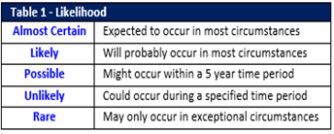 | 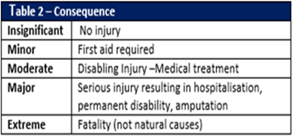 | 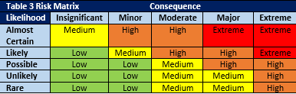 | 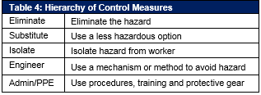
SIGN OFF GUIDE
Low – Medium = Safe to proceed | High = Unsafe, controls must be reviewed / signed off  Activity may have conditions applying. | Extreme = Unsafe do not attempt activity

